Install Plan: | Structured Wiring Detail for patch cable & cross over cable 10 Base T
Candidate: |  |  |  | Machine ID:
Venue: |  | Date: |  | Time:

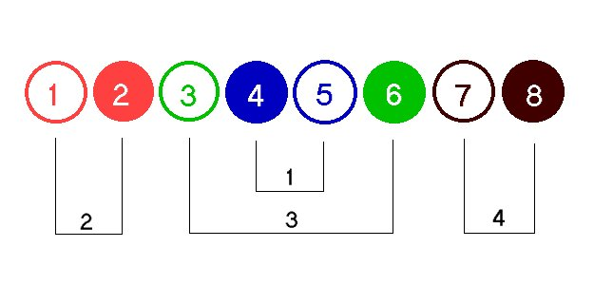
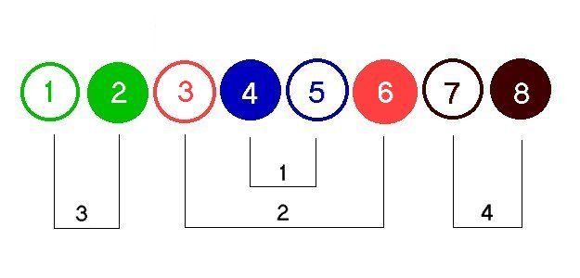
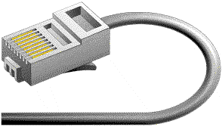

EIA 568B

EIA 569B has become the most widely specified sequence world wide for new data installations.
It is also a sub-set specified by the IEE 802.3 10BaseT Ethernet over twisted pairs standard.

EIA 568A

EIA 568A This is the newest of the sequence options as published in the EIA Commercial Building Cabling Specification Draft 9.0 as the preferred sequence of UTP data cabling.
(This is similar to the 568B sequence except pairs # 2 and #3 are transposed.) This provides backward compatibility for two pairs instead of a single pair of 568B.

Combining the EIA568B & EIA588A to a single cable, with RJ45 connectors, this will
provide a cross over cable to connect two computers (stations) via 10/100 Base T Ethernet

Candidate signature |  | Date:
Supervisor signature |  | Date:

